Massachusetts Alliance Against Predatory Lending
Member Group Priorities

2015 MORTGAGING & FORECLOSURE LEGISLATION
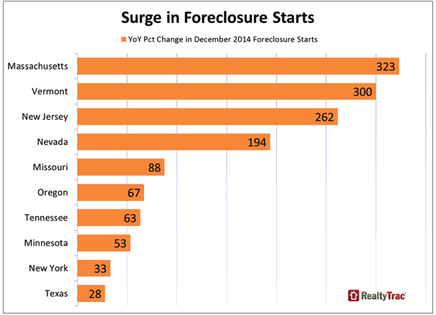
Why we need and are ready for fundamental solutions:
Foreclosures are back up! December 2014 figures were up across the country, year-on-year, but nowhere as much as in Massachusetts at 323%.

While the looseness of subprime mortgage lending attracted huge worldwide investment, the huge inflationary pressure of subprime mortgage incentivizing and this influx of capital led to vastly overpriced homes! Lending based on this overpricing and the peaking of housing values then created the snowballing foreclosures and property loss for which we are still paying. See this graph from the Boston Federal Reserve:
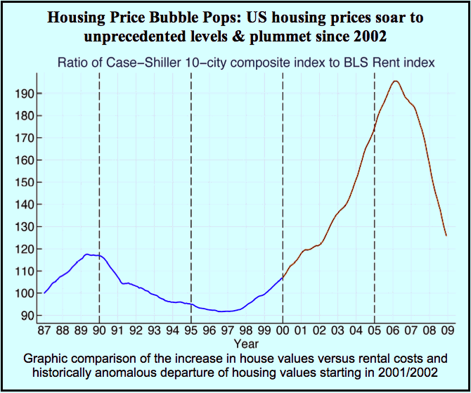

Overpriced mortgage payments were unsustainable for certain borrowers, especially when housing prices started to drop. Those with subprime mortgages were underwater. Homeowners' budgets were drained and many, prime mortgagors as well as subprime, lost their homes.

We can provide the tools to unravel this mess – fairly, and in a way that will return $Billions to our state. The Mass Alliance Against Predatory Lending (MAAPL) is presenting nine legislative measures for the purpose this session and we need your support.

- Preventing Unnecessary Vacancies, S807/H1579: Sen. Eldridge and Rep. Sanchez

This Bill requires a commercial purchaser of a foreclosed home to rent it to the “foreclosed” homeowner until the property is sold to a new owner-occupant. The former owners become tenants paying the HUD fair market rent for their units. Post-foreclosure tenants can be evicted only for just cause.

- Facilitating Alternative to Foreclosure/Mediation, S482/H888: Sen. Chandler & Rep. Keefe

This Bill establishes a statewide, pre-foreclosure mediation program, available to homeowners as of when they receive their default/right to cure letter. The foreclosing party must provide legal documents proving that it actually owns the mortgage and a representative with the authority to negotiate the full range of settlements. In Connecticut, 78% of homeowners who participate in such mediations get affordable payment plans to stay in their homes long term. Another 13% get a mutually agreeable alternative to foreclosure.

- Foreclosure Review Division of Superior Court, S871/H1640: Sen. McGee and Rep. Vega

This Bill establishes a statewide, specialized division of Superior Court to adjudicate all aspects of foreclosure-related cases, instead of the several courts that now have jurisdiction over one or another aspect of such cases. The Foreclosure Review Division will be empowered to clear title to foreclosed properties, both for those foreclosed and for third-party purchasers, and will provide on-line and other assistance to pro se litigants. It will free up regular court dockets and promote judicial economy.
- Reliable Land Title Act, S805/H1625: Sen. Donoghue & Reps. Swan and Story

This Bill protects real estate titles; its provisions ensure, for instance, that the mortgagor (borrower) can always tell who owns the mortgage, and require the Mortgage Note to be returned to the mortgagor, marked “Paid in Full,” upon payoff. It requires Registries of Deeds to record each mortgage in the names of the real parties in interest, that is, the mortgagor and lender. It institutes deadlines for recording assignments of mortgage and foreclosure deeds. Protecting marketable title will bolster business creation by facilitating entrepreneurs’ mortgages on their own homes: these historically have provided up to 70% of the credit for new U.S. businesses.
- Tax Relief of Mortgage Debt, S1464/H2607: Sen. DiDomenico and Rep. Malia

When a homeowner’s mortgage ends in foreclosure, tax law regards the debt as paid off up to the amount paid at foreclosure. This debt “forgiveness” is accounted as a profit to homeowners who just lost their homes and likely largest investment of their lives. Congress changed federal tax law to exempt homeowners from being taxed as if that is a profit. This Bill creates the same tax exemption at the state level.
- Property Tax Taking of Home, S1463/H2605: Sen. DiDomenico and Rep. Mahoney

Municipalities have often allowed delinquent owners to pay real estate taxes late or make long payment plans. Now municipalities are enforcing quickly, sometimes selling tax title debt to unregulated individuals. Owners are unaware that if third party investors foreclose their homes in Land Court, their homes cannot be redeemed. This Bill requires: (1) explicit notices to homeowners with an alert in the 5 most common languages other than English; (2) licensing tax title purchasers as debt collectors; (3) 1 year redemption period after Land Court foreclosure; (4) a third-party tax title buyer who forecloses in Land Court must auction the property publicly, with net proceeds split between the municipality and past owner.
- Muni Vacant & Foreclosed Programs, S1090/H1498: Sen. L'Italien & Rep. Frank Moran

This Bill defines additional municipal options given existing municipal powers to specify or extent state sanitary code requirements as necessary for residents’ health and safety. It outlines registering and securing and/or refundable cash bond programs for owners of vacant, foreclosing and foreclosed properties. The huge upsurge in vacant properties in our state has made fronting money for upkeep, securing and code enforcement of neglected properties prohibitive for Cities and Towns. Programs have been instituted for registration in many communities and for refundable cash bonds for over 5 years in Worcester and recently in Lynn, Lawrence, and Springfield.
- Judicial Foreclosure, S852/H1599: Sen. Kennedy and Rep. Smizik

This Bill requires foreclosure of 1 – 4 family homes to be conducted through a court action. A party wishing to foreclose must provide the legal documentation to prove to a judge that it is the mortgage-holder before it forecloses. With our present non-judicial foreclosures, the burden is on a wronged homeowner to get a judge to order the foreclosing party to produce this evidence. Judicial Foreclosure will prevent foreclosures by those with no authority to foreclose, and prevent clouds on title presently created during non-judicial foreclosures.
- Resolution Trust Fund, H835: Rep. DuBois

This Bill establishes a dedicated Trust Fund into which borrowers can pay when they prove that no bank can legally claim their mortgage payments. Annual statewide hearings would determine how to use Trust Fund monies to rebuild housing and businesses in areas hard hit by foreclosures. As funds increase, these hearings will be held regionally and the monies used to rehabilitate the areas from which they originate.
maaplinfo@yahoo.com www.MAAPL.info
Legislative Contact: Grace Ross, 617-291-5591

MAAPL Members/Supporting Organizations: Action for Boston Community Development, Inc., Action for Regional Equity, Alliance of Providers of Legal Services to Individuals Facing Foreclosure, ARISE for Social Justice, Arlington Community Trabajando, Boston Tenants Coalition, Brazilian Women's Group, Brockton Interfaith Community, Carpenters Local 40, Carpenters Local 107, Charles Hamilton Houston Institute For Race & Justice, Chelsea Collaborative, Chinese Progressive Association, City Life/Vida Urbana, Coalition for Social Justice, Community Economic Development Ctr of S.E. MA, Community Labor United, Democratic Socialists of America, Dorchester People for Peace, Era Key Realty Services, ESAC, Fair Housing Center of Greater Boston, Greater Boston Legal Services, Greater Four Corners Action Coalition, Green-Rainbow Party of MA, Harvard Legal Aid Bureau, Homeowner Options for MA Elders, Jewish Alliance for Law and Social Action, Lawrence Community Works, Lawyers' Committee for Civil Rights Under Law, Lynn United for Change, Legal Assistance Corporation of Central Mass, Mass Advocates for Children, Mass AFL-CIO, Mass Coalition for the Homeless, Mass Community Action Network, Massachusetts Fair Housing Center, Mass Jobs With Justice, Mass Law Reform Institute, Mass Welfare Rights Union, Merrimack Valley Labor Council, NAACP N.E. Area Council, National Community Reinvestment Coalition, National Consumer Law Center, National Lawyers Guild, Neighbor-to-Neighbor, Neighborhood Legal Services, New England United for Justice, North Shore Labor Council, ¿Oiste?, Organization for a New Equality, Painters District Council 35, Pleasant St. Neighborhood Network Center, Southbridge Community Connections, Springfield No One Leaves Coalition, Survivors Inc., Tri-City Community Action Program, UE Northeast Region, Union of Minority Neighborhoods, United Auto Workers Mass CAP, United Food & Commercial Workers 1445, United For a Fair Economy, United Steel Workers Local 5696, Volunteer Lawyers Project, Worcester Anti-Foreclosure Team

